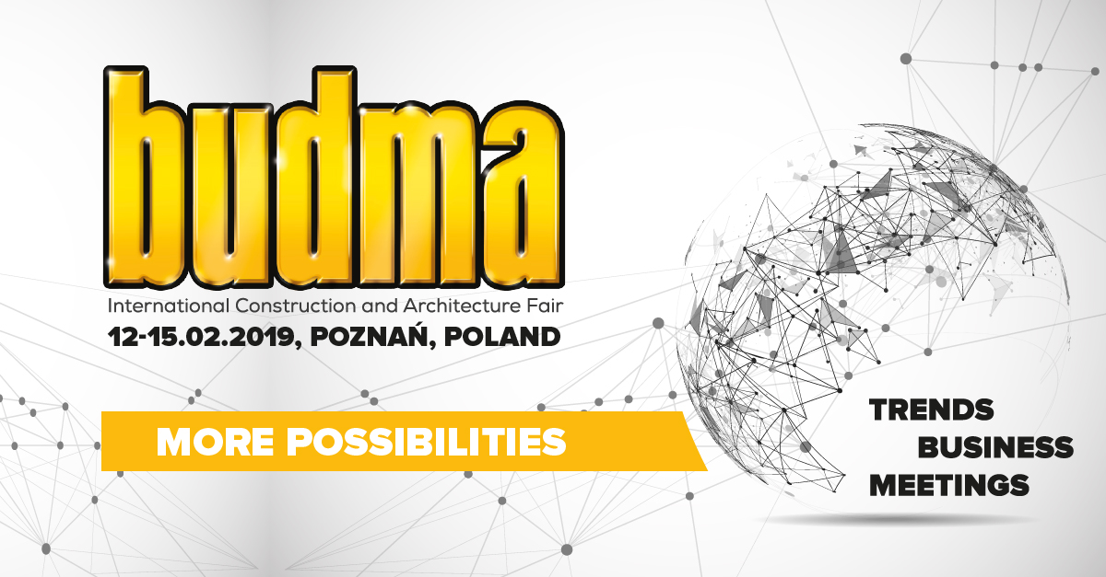
BUDMA. Trends, meetings, business!
Nearly 50.000 professionals and 1.000 exhibitors, 43 products awarded with the prestigious MTP Gold Medal, over 150 market premieres, interactive events, and above all the power of business talks at the stands. This is how the BUDMA International and Architecture Fair, which took place on February 12-15, 2019 in Poznań (Poland) can be briefly characterized.
BUDMA architecturally
During Design & Architecture Forum D&A architects and designers had the unique opportunity to listen to the lectures of such world-famous artists as Giuseppe Blengini, Emilio Nanni and Marcantonio Malerba. Moreover, nearly 100 architectural studios created an interesting review of the latest concepts for future investors under the name 1m/ARCH. The forum was also accompanied by an architectural debate entitled "Ecology, sustainable development, innovation. Architectural challenges in the 21st century”, in which the renowned Polish architects tried to answer the questions.
Fair for professionals
Professionals who came to Poznań for the BUDMA Fair were charmed by the exhibitors with hundreds of new products and market premieres, and the organizers and partners invited roofers, parquet fitters and assemblers of construction joinery to attend special events.
Taking active part or watching the Parquet Flooring Championships in an international cast (International Champion of Poland title won Dzmitri Pisarau from Belarus, second place was taken by Krzysztof Ratka from Poland, bronze went to Maksim Ananich from Belarus), Monteriada (shows of the best joinery assembly practices) and Turbo Roofer competition could improve their professional skills. There were many more such places - in special exhibition and workshop zones, every professional had the opportunity to try and test the advantages of innovative construction equipment, tools and materials in "working" conditions, as well as to obtain additional, valuable information directly from their producers.
Conferences, presentations, consultations
In a special Health & Safety on the construction site zone, experienced experts and exhibitors offering equipment and services in this area have addressed the most important issues for maintaining safety in the implementation of construction projects. This topic was also taken as part of the conference "BUILD SAFELY. Limiting hazards when working at heights." Partners of the BUILD WITH STEEL Program invited to the seminar, during which the topic of "Innovation in steel construction" was taken up by representatives of leading companies in this industry.
WinDoor-tech - technologies of the future
“Technologies of the future” was the main motto of this year's WinDoor-tech Fair. The organization of the event together with the BUDMA Fair gave the effect of synergy. In one place and time have presented their offer companies dealing with the production of construction joinery and suppliers of the latest technologies, solutions and systems, being the world leaders in this segment. For another year in a row, Poland is the most important window manufacturer in Europe. The WinDoor-tech Fair reflected the good situation in the industry, hosting a record number of exhibitors from around the world.
The next edition of the BUDMA Fair, the largest event for construction industry in Central and Eastern Europe, will take place on 4-7 of February 2020.
www.budma.pl

